Date of planning: ….. /….. /
Date of teaching: ….. /…../
Week 35
Period 69- 70 REVIEW (2nd Semester)
- Objectives:
After completing this lesson, students will be able to:
- Language competence
Review Unit 6 to Unit 10 to prepare for the 2nd semester test
- Core competence
- Build up interests and good habits in learning English
- Build up responsive and independent-working characteristics to be a long-life learner
- Be supportive and collaborative in team work
- Demonstrate problem-solving and communicative skills through learning activities
- Personal qualities
- Build up respective attitudes to others in the community
- Build up spirits of the responsibility for family and the community
- Teaching aids:
Teacher’s aids: student book and teacher’s book, class CDs, flashcards, IWB software, projector/interactive whiteboard/TV.
Students’ aids: Student books, notebooks, workbooks.
- Procedures:
Time | Steps/Activities | Organization
5’ | Warm-up  Sing “What day is it today?” song  (Source: English Singing  https://www.youtube.com/watch?v=RfAMjbaHMVU) | - Teacher – whole class
5’ | Option 1:  “Hangman” game  - Split the class into two teams.  - Draw the hangman board and draw blank spaces for the word the teacher wants them to guess.  - Have each team guess a letter. If they guess it right then they get one point for each letter in the word. If they get it wrong then draw a head, body, 2 legs and 2 arms.  - When the teacher draws all the parts of body the game is over and the teacher starts a new game.  - The winner is the one with the most points at the end of the last puzzle. | - Teacher – Whole class/ groupwork
5’ | Option 2:  "Inside the bag" game  - Prepare some cards, writes out some actions (count numbers, draw pictures, spell words, sing songs) on the back, then, put them in four bags. Give each team a bag.  - Divide the class into four teams.  - Have each student comes to the front of the class and choose a card from the bag. Then, say out a sentence with a corresponding action (E.g. I can (draw pictures).) then try to pretend that.  - Continue with other students.  - The first team to finish making the sentences with all the cards correctly wins. | - Teacher – Whole class/ groupwork
 | New lesson
25’ | - Give each student a worksheet.  I. Look. Draw lines.  - Have students look at the pictures and call out what they can see.  - Demonstrate the activity using the example.  - Have students match the pictures with the corresponding letters.  - Check answers as a whole class. | - Teacher – Whole class/ individuals
 | “Draw and Roll” game  - Arrange the class into four lines.  - Secretly show a flashcard to the first child in each line.  - This child runs to the board and draw the object.  - The last child in the line tries to guess and picks the requested object then says a sentence. (E.g.I can see a yo-yo.)  - The fastest student to pick the correct object rolls the die then get the corresponding point. | - Teacher – Whole class/ groupwork
 | II. Look. Answer.  - Divide the class into pairs.  - Have Student A read the questions.  - Have Student B answer and write down the words to complete the answers.  - Swap roles.  - Check answers as a whole class. | - Teacher – Whole class/ individuals/ pair work
 | III. Look. Write.  - Divide the class into pairs.  - Have Student A read the sentences.  - Have Student B write down the missing words.  - Swap roles.  - Check answers as a whole class. | - Teacher – Whole class/ individuals/ pair work
5’ | Wrap up
 | “Vanishing Flashcards” Game  - Divide the class into four teams.  - Place flashcards on the board.  - Give them a moment to memorize the flashcards and then tell them to close their eyes.  - Take away one of the flashcards and then tell the students to open their eyes again.  - The teacher asks a question relating to the flashcard.  - The first student who answer correctly gets one point for his/her team.  - The first team to have the most points wins. | - Teacher – Whole class/ groupwork
 | Sing and dance the song “Goodbye School”  (Source: Dream English Kids  https://www.youtube.com/watch?v=WyfH-wwJUcY) | - Teacher – Whole class

WORKSHEET
- Look. Draw lines.
 |  | V |  | 
 |  | W |  | 
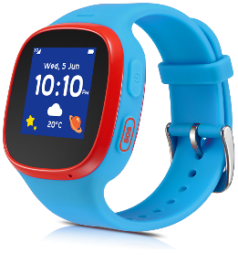 |  | X |  | 
 |  | Y |  | 
 |  | Z |  | 
- Look. Answer.

 | 
- Can you see a bus?  Yes, I can.  __________________ . | - Can you see a train?  __________________ .
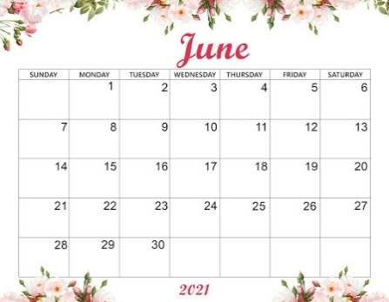
- What day is it today?  It’s _____________ . | - What day is it today?  It’s _____________ .

- Look. Write.
 | 
1. I want to go to the ______________.  beach | 2. These are my _____________.
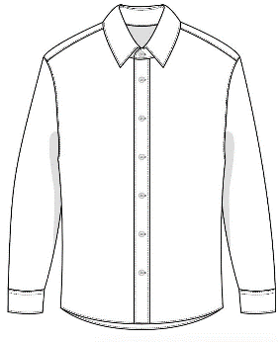 | 
3. Is this a shirt?  ________________. | 3. Is this a watch?  ________________.

