Date of planning: ….. /….. /
Date of teaching: ….. /…../
Week 34
Period 68 REVIEW (2nd Semester)
- Objectives:
After completing this lesson, students will be able to:
- Language competence
Review Unit 6 to Unit 10 to prepare for the 2nd semester test
- Core competence
- Build up interests and good habits in learning English
- Build up responsive and independent-working characteristics to be a long-life learner
- Be supportive and collaborative in team work
- Demonstrate problem-solving and communicative skills through learning activities
- Personal qualities
- Build up respective attitudes to others in the community
- Build up spirits of the responsibility for family and the community
- Teaching aids:
Teacher’s aids: student book and teacher’s book, class CDs, flashcards, IWB software, projector/interactive whiteboard/TV.
Students’ aids: Student books, notebooks, workbooks.
- Procedures:
Time | Steps/Activities | Organization
5’ | Warm-up  Sing the song “ Jump, Run and Shout”  (Source: The Singing Walrus  https://www.youtube.com/watch?v=hft6uJQIF4g) | - Teacher – whole class
5’ | Option 1:  "Whispering" game  - Divide the class into four teams.  - Have students from each team stand or sit in a row.  - Whisper a question to the first students in each row.  - Have the first students whisper the question to the second students.  - Have teams continue whispering the question until it reaches the last students.  - The last student in the row has to say out the question and answer it.  - Give the first team to say the question and answer correctly one point.  - The team that gets the most points wins. | - Teacher – Whole class/ groupwork
5’ | Option 2:  Drawing and guessing  - Divide the class into four teams.  - Have each team stand in a line.  - Secretly show a flashcard to the first child in each group. This child runs to the board, draw the picture.  - Have the other students in his/her team try to guess what the picture is.  - The first team has the correct answer will get one point. | - Teacher – Whole class/ groupwork
 | New lesson
25’ | - Give each student a worksheet.  I. Look. Read. Write.  - Have students look at the pictures and call out what they can see.  - Demonstrate the activity using the example.  - Have students choose the correct words from the box and write under the corresponding clothes.  - Check answers as a whole class. | - Teacher – Whole class/ individuals
 | II. Look. Read. Complete.  - Have students look at the pictures and call out the things and activities they can see.  - Demonstrate the activity using the example.  - Have students choose the correct words or phrases from the box to complete the sentences.  - Check answers as a whole class. | - Teacher – Whole class/ individuals
 | III. Look. Read. What’s next? Write.  - Divide the class into four groups.  - Invite one student from each group to come to the board.  - Explain that the four students are going to race to write the answers from their worksheets.  - The first student who finishes all the blanks correctly gets one point for his/her team.  - Continue in the same way.  - Have students complete their worksheets. | - Teacher – Whole class/ individuals/ groupwork
 | IV. Unscramble the sentences.  - Divide the class into pairs.  - Have Student A read questions.  - Have Student B complete the answers and write down on his/her worksheet.  - Swap roles.  - Check answers as a whole class. | - Teacher – Whole class/ individuals/ pair work
5’ | Wrap up
 | Option 1  "Word Tennis" game  - Have one student come to the front and play with you.  - Say a word from unit 6 - 10, and pretend to hit a ball to the student. Have the student respond with another word and hit it back to you. Continue until someone repeats a word or can't go.  - Divide the class into pairs and have them play with each other.  - Have some pairs demonstrate the activity in front of the class. | - Teacher – Whole class/ individuals
 | Option 2  “Asking race” game  - Divide the class into four teams and have them stand in four lines.  - Invite one student from each team come to the board.  - Give four students the same amount cards. The students who received the cards have to show cards to his/her friends and ask questions about the given cards. (E.g. What day is it today?)  - The first student in each line answers the first question. If his/her answer is correct, he/she will get that card from his/her friend then run to the bottom of the line.  - The second student answers the second question and so on.  - The first team that finishes asking and answering wins the game. | - Teacher – Whole class/ groupwork

WORKSHEET
- Look. Read. Write.
a T-shirt | shoes | trousers
shorts | a dress | a coat

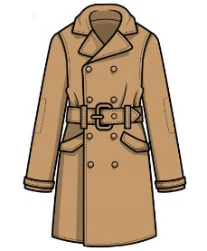  a coat | 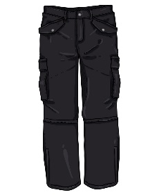 | 
1._______________ | 2._______________ | 3._______________
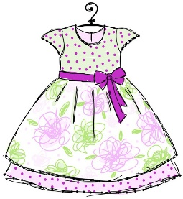 | 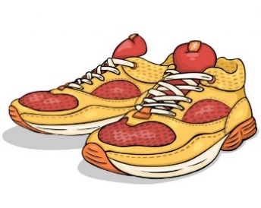 | 
4._______________ | 5._______________ | 6._______________

- Look. Read. Complete.

an eraser | spell words | count numbers
pencil case | ruler | draw pictures

  draw pictures | 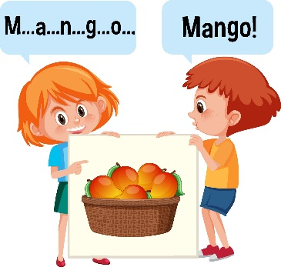 | 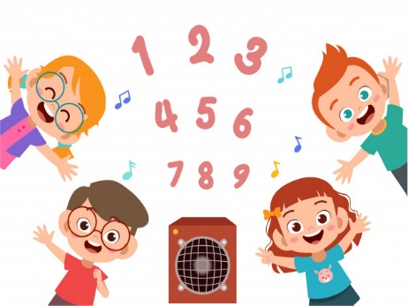
1.I can _______________ . | 2.I `can _________. | 3.I can ___________.
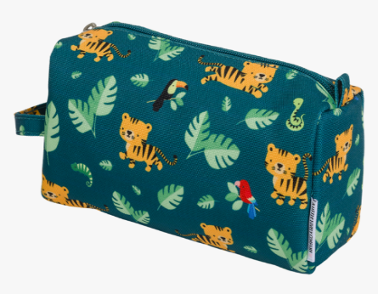 | 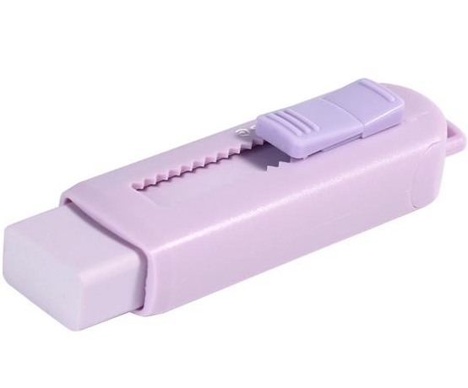 | 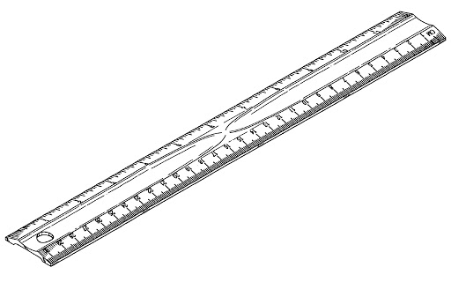
4. Pick up _____________. | 5. Pick up _____________ . | 6.Pick up _______________ .

- Look. Read. What’s next? Write.

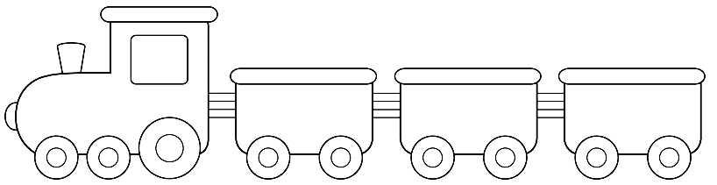
……………
Saturday
Friday
……………

1.

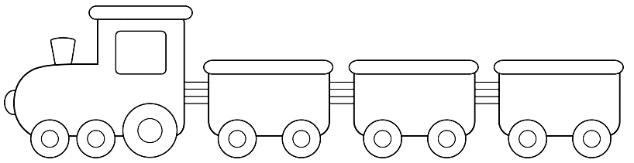
Monday
……………
Wednesday

2.

Wednesday
……………
Friday

3.

IV. Unscramble the sentences:
Example: shoes / These / my / . / are
These are my shoes.

1. sock / . / are / These / my

2. the / ? / Can / see / boat / you

3. can’t / No, / . / I

4. up / your / . / Pick / ruler

