Week 26
Period 103- 104 REVIEW 3

I. Objectives: By the end of this unit pupils can
- Listen and identify specific information related to the theme: Me and my family.
- Read and identify specific information related to the theme: Me and my family.
- Use simple sentences to write about themselves.
- Listen and tick the correct pictures.
- Listen and number the pictures.
- Listen and write one word in the blank.
- Read the paragraph and complete the table.
- Write about themselves, using the guiding questions.
II. Language focus
- Vocabulary: Unit 11 - 15
- Sentence patterns: Unit 11 - 15
III. Teaching aids
1. Teacher’s: student’s and teacher’s book, pictures, cassette.
2. Students’: books, notebooks, workbooks.
IV. Procedures
Content | Teacher’ s activities | Student’s activities
A. Warm up  (5’)  B. New lesson  (30’)  C. Production  (3’)  D. Homework  (2’) | - Ask pupils tochant: What would you like to be in the future?  Task 1. Listen and tick.  - Ask pupils to identify each character and what’s the matter with him/ her or what he/sheis doing.  - Tell pupils that they are going to listen to the recording and write the correct pictures.  - Play the recording all the way through for pupils to listen.  - Play the second time and ask pupils to do the task.  - Ask pupils to give answers  - Play the recording again for pupils to listen and check  - Give correct answers.  * Key: 1. b 2. c  Task 2. Listen and number  - Tell pupils that they are going to listen and number the pictures in the order they here.  - Play the recording two times for pupils to listen.  - Play it again for them to number the pictures.  - Get pupils to compare their answers before checking as a class.  - Give answers.  * Key: a 2 b 1 c 4 d 3  Task 3. Listen and write one word in the blank  - Tell pupils that they are going to listen and write one word in each gap.  - Ask pupils toread the sentences in silence in their book and guess the answers based on the surrounding words.  - Play the recording the first time all the way through for pupils to listen and write.  - Play it the second time for pupils to listen and check their answers.  - Give the correct answers.  * Key: 1 design 2 reading  Task 4. Read and complete.  - Tell pupils that they are going to read the text and complete the table.  - Give pupils time to look at the table in theirs book and think of the information needed to fill the gaps.  - Ask pupils to read the text in silence and complete the table.  - Get pupils to compare their answers in pairs before checking as a class.  - Give explanations, if necessary.  * Key: 1. pilot  2.wants to fly planes 3. reads books  4. would like to write stories for children  5. draws pictures  Task 5. Write about you  - Tell pupils that they are going to write sentences about themselves.  - Give them time to read the questions in silence, then complete the sentences about themselves.  - Call three pupils to read the answers aloud in front of the class. Ask others to listen and give comments.  - Give feedback.  - Summary the lesson  - Ask pupils to do exercises in workbook. | - Let’s chant  - Look at the pictures  - Listen to the recording.  - Listen to the recording and do the task.  - Give answers  - Listen and check.  - Listen to T.  - Listen to the recording  - Number the pictures.  - Compare the answers.  - Read the sentences in silence and guess the answers.  - Listen and wirte  - Listen and check  - Look at the book  - Read the text in silence and complete the table.  - Compare the answers in pairs  - Read the questions in silence and complete the sentences.  - Read the answers aloud  - Take note

Week 27
Period 105 SHORT STORY
CAT AND MOUSE 3
I. Objectives: By the end of this unit pupils can:
- Read and listen to the short story.
- Answer the questions.
- Unscramble the words from the story.
- Read and complete the conversation.
- Work in pairs. Imagine they are sick. Talk about how they feel.
- Read and match the questions with the answers.
II. Language focus
- Vocabulary: Unit 11 - 15
- Sentence patterns: Unit 11 - 15
III. Teaching aids
1. Teacher’s: student’s and teacher’s book, pictures, cassette.
2. Students’: books, notebooks, workbooks.
IV. Procedures
Content | Teacher’s activities | Student ‘s activities
A. Warm up  (5’)  B. New lesson  (30’)  C. Production  (3’)  D. Homework  (2’) | Task 1. Read and listen to the story  - Tell the class that they are going to read and listen to the story.  - Ask pupils to look at the pictures and ask them question:  Where are Chit and Miu? What’s the matter with Miu? What’s Miu going to do with Maurice and Doris? Where’s Mauris? What’s the matter with him?  - Play the recording three times for pupils to listen and follow in their books.  - Play it again for them to listen and repeat  - Then ask them to practice the conversation in groups of three.  - Call on some groups to practice the dialogue.  - Give feedback.  Task 2. Answer the questions  - Tell pupils that they are going to answer the questions about the story.  - Give them time to look at the story again, then read the questions and answer them in pairs.  - Invite some pairs to ask and answers aloud.  *Key:  1. No, he isn’t.  2. He has a headache, a stomach ache and a fever.  3. He’s going to the zoo with Maurice and Doris.  4. No, they can’t.  5. He can stay in bed.  Task 3. Unscramble these words from the story  - Tell pupils that they are going to put the letters in the correct order and write the words from the conversation in Activity 1.  - Give them time to do the task. Give the first letters of the words, if necessary.  - Call some pupils to go to the board and write their answers  - Give correct answers  Key: a. headache d. because  b. terrible e. matter c. speaking  Task 4. Read and complete  - Tell pupils that they are going to read and complete the gapped sentences.  - Give them a few seconds to read the conversation in silence.  - Set a time limit for them to do the task. Tell them to read the story again if they do not know the answers.  - Give correct answers  * Key:  1.well 2.matter 3. have  4.stay 5. not  Task 5. Work in pair. Talk about how you feel  - Tell pupils that they are going to practice talking about how they feel when they are sick.  - Give them time to do the task in pairs.  - Invite a few pairs to act out the dialogues. Correct the pronunciation, if necessary  Task 6. Read and match  - Tell the class that they are going to read and match the questions with the answers.  - Ask pupils to do the task in silent.  - Call two pupils to write their answers on the board.  - Ask pupils to swap and check their answers.  * Key: 1.e 2.a 3.b 4.c 5.d  - Summary the lesson  - Ask pupils to do exercises in workbook. | - Answers the questions  - Listen, and follow in the book  - Listen and repeat  - Work in groups  - Practice the dialogue  - Work in pairs  - Ask and answer in front of class  - Do the task  - Write the answers on the board  - Read the conversation in silence.  - Do the task.  - Listen to the Teacher.  - Work in pairs  - Act out the dialogues  - Do the task in silent  - Write the answers on the board  - Swap and check the answers.  - Listen  - Take note

Week 27
Period 106- 107 TEST 3

I. Look and read. Choose the correct word or phrase to fill the gaps as example.
post office |  | teacher |  | summer
knife |  | Maths |  | toothache

1. It is a place where people buys stamps and envelops. ……....
2 .Tony has a pain a tooth. ................
3. It’s usually very hot in this season................
4. He is a person who teaches pupils at school................
5. Don’t play with it . You may cut yourself. …….....
II. Order the words.
- I / stomachache/ have /a/.  →……………………………………………………………… | 
- like / to /Ha Long Bay / I’d / visit/.  →……………………………………………………………… | 
- family/ An Tiem’s / the/ for/ and/ watermelons/ food/ exchanged/ drink/.  →……………………………………………………………… | 
- to / an /in the future/ want / architect / be / I/.  →……………………………………………………………… | 
III. Look at the picture. Write ONE word for each gap.
1 . | Phong and Nam often go _________________ in their free time.

2.  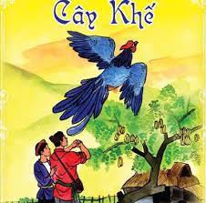  3. | I am reading _______________________________.
  4. | I’d like to be an _____________________ because I’d like to design buildings.
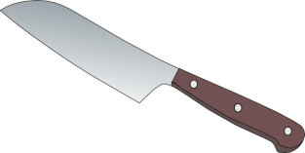 | You shoudn’t play with the……….because it may cutyourself.

II. Look, read and tick Yes/ No (1pt) (Nhìn và đánh dấu Yes hoặc No)
How to stay healthy |  |  |  | Yes | No
0. You shouldn’t do morning exercise in the morning. |  |  |  |  | √
1. You should brush your teeth once a day.
2. You should wash your hands before and after meals.
3. You should take a shower twice a week.
4. You should eat a lot of fresh vegetable.
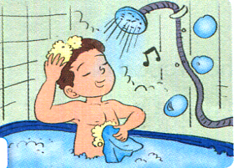 | 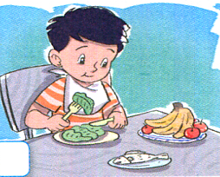 | 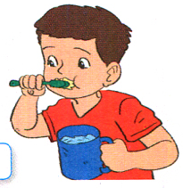 | 