Week: 3 Date of planning: / /2022
Period: 11 Date of teaching: / /2022
UNIT 2: OUR NAMES
Lesson 1 (1-2-3)
- Objectives:
By the end of the lesson, students will be able to:
1. Knowledge:
- Use the words what, your, name, my in relation to the topic “Our names”;
- Use What’s your name? – My name’s . to ask and answer questions about names;
- Listen to and demonstrate understanding of simple communicative contexts in relation to the topic "Our names";
2. Competences:
- Critical thinking: talk about names.
- Oral communication: speak about names, ask and answer the questions
3. Attributes/ Qualities:
- Diligence: complete learning tasks
- Leadership: collaborate with teachers to enhance language skills
II. Preparation.
1. Teacher’s preparation: CDs player, stereo, book.
2. Student’s preparation: Students’ aids: books, notebooks, workbooks.
III. Procedures
Teaching and learning activities | Classroom management
* Warm-up and review: 5’  Greet the class.  Sing the song Hello in Unit 1 Lesson 1  - Ask pupils to sing the song.  - Invite some of them to come to the board to role play, the rest of the pupils will sing. | Whole class
A. PRESENTATION  * New lesson:  Activity 1. Look, listen and repeat. (8 minutes)  Goal: - To understand and correctly repeat the sentences in two communicative contexts (pictures) focusing on asking and answering questions about names.  *Set the context:  - Have pupils look at Pictures a, b and identify the characters in the pictures.  - Ask pupils to look at Picture a. Play the recording for them to listen.  - Play the recording again for pupils to listen and repeat in chorus, sentence by sentence. Follow the same procedure with Picture b. Correct their pronunciation where necessary.  - Invite a few pairs role play.  - Draw their attention to the question What’s your name? and the answers My name’s Ben. and My name’s Mary. Tell pupils that they are a question and answers about the character names.  1. Vocabulary:  - What (explanation)  - Your (explanation)  - My(explanation)  - Name(ex)  Check vocabulary: Rub out and Remember  2. Model sentences:  Asking and answering questions about someone’s names  A: What’s your name?.  B: My name’s Mai.  Note: What’s = What is  Name’s = name is  - Practice reading the model sentences.  - Check meaning, form, intonation.  - Have Ps copy down in their note books  B. PRACTICE  Activity 2. Listen, point and say. ( 9 minutes)  Goal: - To correctly say the character names and use What's your name? - My name's . to ask and answer questions about names.  - Ask Ss look at the picture a and b. Elicit the name of each character.  -Have pupils point at Picture a (Nam, Bill), listen to the recording and repeat the names (Nam, Bill). Follow the same procedure with Picture b. Have the class repeat the names a few times.  - Point at the first bubble and have pupils listen and repeat after the recording (What's your name?). Point at Picture a and have pupils listen and repeat after the recording (My name's Nam). Follow the same procedure with Picture b.  - Put pupils in pairs and have pairs practise asking and answering the question What's your name? - My name's .  -Invite a few pairs to point at the pictures and say the questions and answers in front of the class.  C. PRODUCTION  Activity 3. Let’s talk. 8 minutes  Goal: - To enhance the correct use of What’s your name? and My name’s . to ask and answer questions about names.  - Draw pupils’ attention to the two speech bubbles. Read the question aloud and ask pupils to repeat it. Ask pupils to look at the second bubble and identify what the answer should be. Elicit the answer My name's Mai. Get pupils to repeat the question and the answer several times in pairs.  -Go around the classroom, point to pupils and ask What’s your name? Allow each pupil to answer with his / her own name (e.g. My name’s Long).  - Have pupils practise asking and answering the questions about their own names in pairs. Go around the classroom to observe and provide help.  - Invite some pairs to practise asking the question and giving the answer in front of the class. | Whole class  Whole class/ Individual work  Whole class/ Individual work  Whole class/ Individual work  Whole class  Whole class/ Individual work  Whole class/ Individual work  Pair work  Whole class/ Individual work  Whole class/ Individual work  Pair work  Individual work  Pair work
Fun corner and wrap-up: (5 minutes)  Game: Let’s ask people around you  Each pupil gets 1 sheet of paper from the teacher. They fill in the information about themselves. Then they can move around the class to ask and answer the questions to know more about their friends’ family member.  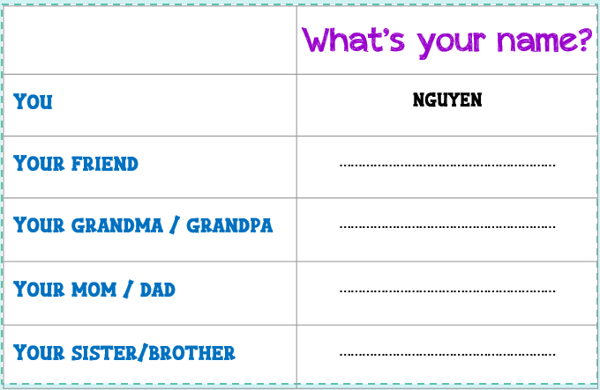  Homelink: Learn by heart vocabulary and practice model sentence | Whole class/ Individual work

IV. Comments:
……………………………………………………………………………………………………………………………………………………………………………………………………………………………………………………………………………………….

Week: 3 Date of planning: / /2022
Period:12 Date of teaching: / /2022
UNIT 2: OUR NAMES
Lesson 1 (4-5-6)
I. Objectives:By the end of the lesson, pupils will be able to:
1. Knowledge:
-Listen to and demonstrate understanding of simple communicative contexts in relation to the topic "Our names";
- read and write about people’s names;
2. Competences:
- Listening: listen and recognize the names, then repeat
- Critical thinking: talk about names.
- Self-control & independent learning: perform listening tasks
- Communication and collaboration: work in pairs or groups
3. Attributes/ Qualities:
- Diligence: complete learning tasks
- Leadership: collaborate with teachers to enhance language skills
II. Preparation.
1. Teacher’s preparation: CDs player, stereo, book.
2. Student’s preparation: books, notebooks, workbooks.
III. Procedures
Teaching and learning activities | Classroom management
* Warm-up and review: 5’  Game: Pass the ball  - Divide the class into 3 teams.  - Each team has 1 sticky ball.  - Play the music. Pupils in each team take turns to pass the ball. When the music ends, 3 pupils who have the ball will stand up and say their names, using the model sentences. | Individual work/ Group work
*New lesson:  Activity 4. Listen and tick. 8 minutes  Goal: To listen to and understand two dialogues in which pupils ask and answer questions about names.  - Ask pupils some questions about Activity 4 (e.g. How many pictures are there? Who can you see? What are they doing?). Ask them to say about the difference between Picture 1a and Picture 1b.  - Have pupils look at Pictures 1a and 1b. Play the recording of the first dialogue and ask pupils to tick the correct picture. Play the recording again and check their answers. Praise pupils if they have the correct answer (Picture b).  - Repeat Step 2 with the second dialogue.  - Set a time limit for pupils to swap and check the answers. Correct their answers, if necessary.  Key: 1.b 2. a  Activity 5. Look, complete and read. (9 minutes)  Goal: To complete three target sentence patterns with the help of picture cues.  - Have pupils look at the pictures. Have them identify the characters in the two pictures.  - Have pupils look at the two incomplete exchanges. Draw their attention to the missing words in the sentences.  - Model with Picture 1. Have pupils look at the dialogue. Ask them what is missing in the answer (Lucy). Then have them look at the picture and identify the character’s name. Then have them complete the gap (Hi. My name’s Nam. What’s your name? - My name’s Lucy.)  - Follow the same procedure with Picture 2. Draw their attention to the two gaps in the second exchange.  - Have pupils complete the exchanges individually and ask a few pairs to read them aloud.  Key: 1. Lucy 2. your name; Mary  Activity 6. Let’s play. (8 minutes)  Goal: To review the characters’ names by playing the game Slap the board.  - Tell pupils that they are going to listen for the names of the six pupils and slap the correct flash cards / words as quickly as possible.  - Put the flash cards or write the words of the six pupils on the board.  - Call two or three pupils to the front of the class. Ask them to stand at a certain distance from the board.  - Invite one pupil to the front of the class and ask What's your name? The pupil answers the question with one of the names on the board (e.g. My name's Bill.). Have pupils run to the board and slap the correct flash card / word. The pupil who is the quickest to slap the correct word gets one point. The pupil who has the most points at the end of the game wins. | Whole class/ Individual work  Pair work  Whole class/ Individual work  Individual work/  Pair work  Whole class/ Group work  Individual work  Individual work/ Whole class
*Fun corner and wrap-up: (5 minutes)  . Use sachmem, have pupils look at the words in the picture of the lesson and repeat after the recording.  Homelink: prepare lesson 3 | Whole class
IV. Comments:
………………………………………………………………………………………………………………………………………………………………………………………………………………………………………………………………………

